Appendix 1: Summary of learner survey
- Total number of responses: 436
- Local authorities represented: range from across Scotland, from Shetland in the north to Scottish Borders in the south, Glasgow in the west to Edinburgh in the east.
- Age range of respondents: P5 – S4. 36% of respondents were in S1, making it the largest group represented.
- Gender split: female = 53%, male = 45%, other = 2%.
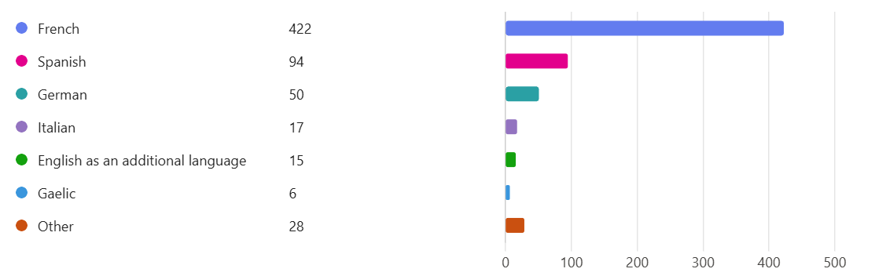
- Languages studied:

- Why they are learning French: A majority replied along the lines of ‘because I have to’. This was not always in a negative way, as later answers for some of these same respondents went on to show interest and enthusiasm for the language, so in some cases this was purely a statement of the situation in their school rather than a comment. In other cases, it was clearly meant negatively.
Examples of other reasons given: because I want to learn it; it’s cool; it’s easier than German/Spanish; it’s fun; because of family connections.
- How they feel about learning French: (more than one answer could be selected)
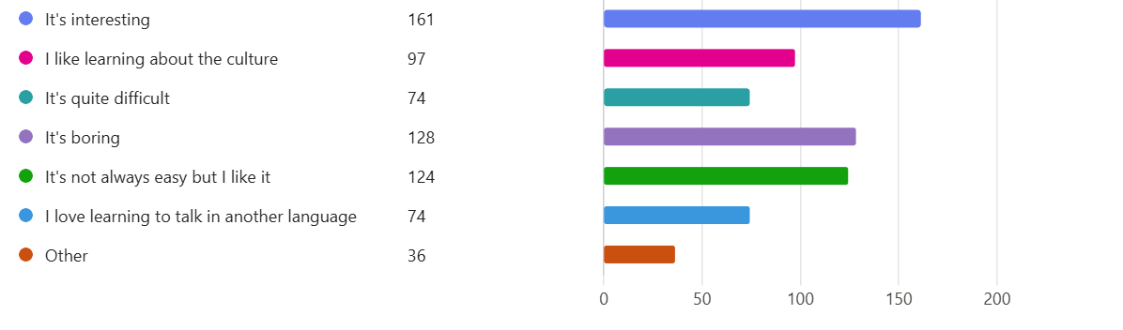

- What they find most difficult about learning French: (as above)
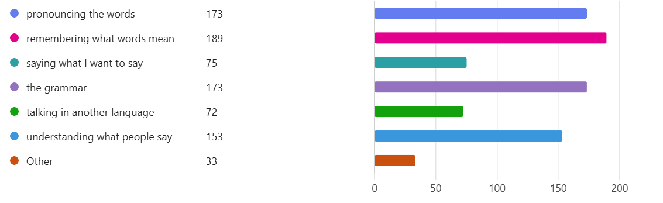

- What they enjoy most about learning French: (and again!)

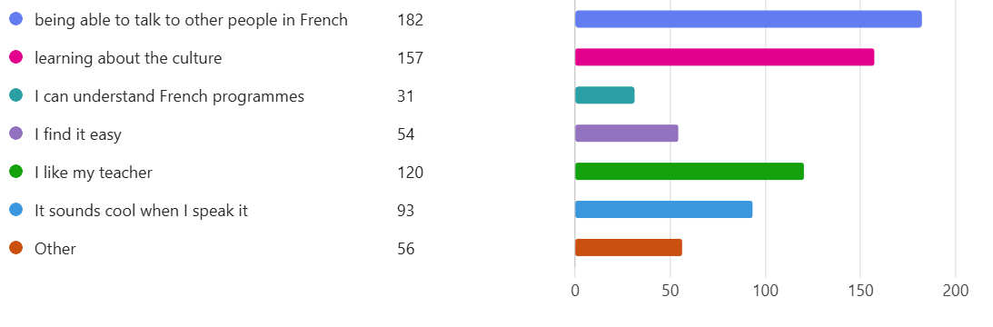
- If they see French in their daily lives: 52% of respondents answered no to this question. Of the other 48%, the most common answer was when gaming, followed by on social media, in sport (particularly football and rugby), on television, and with family.

- What French culture means to them:
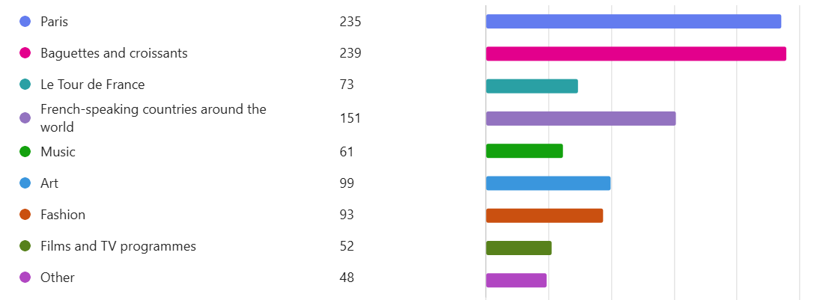
- To them, French culture is:
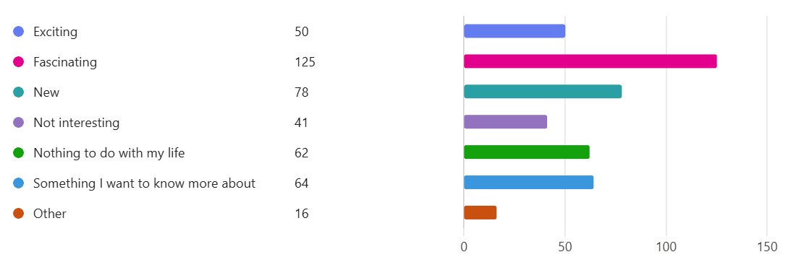
- What they would like to learn about in French classes: By far the most common answers here were a) French culture/ what life is like in France and French-speaking countries, and b) how to actually speak French to others/ how to have normal conversations with people (direct quotes). Variations on these two answers formed the vast majority of this section. A small minority said that there is nothing that they want to learn.

